Chapter 25 Weighted Graph Applications
1.
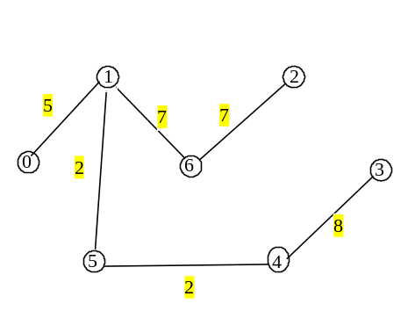
2. Yes

3. O(n^2logn), n is the number of vertices.

4. Omitted

- No. (Can you give an example?)

- O(n^2logn), n is the number of vertices.

- edge.u is 1, edge.v is 2, and edge.weight is 3.5

2.
4.5

3.
3.5
6.5
1.5
4.
1.5
3.5
6.5
5.
The code is wrong because there is no neighbors[0]. You need to first create and add a vector into neighbors using the following statements:
neighbors.push_back(vector<WeightedEdge>());
neighbors.push_back(vector<WeightedEdge>());

After the fix, the output is 0.

6.
7. Yes

8. O(n^2logn), n is the number of vertices.

9. line 126 in WeightedGraph.h, the loop
while (T.size() < getSize()) {
continues if T.size() < getSize(). If the graph is not connected, the loop will not terminate.
Another problem is that u is set to -1 in line 129. If no edges are found to connect vertices between T and V – T, -1 will add to T in line 141.
The way to fix it to obtain a partial MST is to replace line 141 with the following code:
if (u != -1)
T.push_back(v); // Add a new vertex to the tree
else
break; // The tree is not connected, a partial MST is found

10. Omitted
11. No.
- O(n^2logn), n is the number of vertices.
13. line 178 in WeightedGraph.java, the loop
while (T.size() < getSize()) {
continues if T.size() < getSize(). If the graph is not connected, the loop will not terminate.
- cost[v] will be infinity.
- No. cost[i] will be a random value.
- The tree data field in NineTailModel is accessed in WeightedTailModel. A new tree is created in WeightedTailModel.
- Omitted
- Omitted

